

Contractors’ Warehouse Supplemental Supplier Requirements Guide
(Compliance & Routing)

Table of Contents

- General Information 3
- Store Listing 4
- Approved LTL Preferred Carrier Program 5
- Supplier Own Truck 6
- Small Parcel Shipping 7
- Shipment Requirements 8
- Shipment Restrictions 10
- Compliant Deliveries 11
- Fill Rate 13
- Discrepancy Report 14
- Request for Return Goods Authorization 16
- Report Card 17
- Report Card Reconciliation Process 18
- Special Order Program 19
- New Store Requirements 21
- New Supplier On-Boarding 22
- New Item Setup and Delivery 23
- Supplier Item Maintenance 24
- Summary Billing and Payables 25
- Sample Forms 27
  - Purchase Order Cover Page 28
  - Purchase Order 29
  - Discrepancy Report 30
  - Late Purchase Order Notice 31
  - Request for Return Goods Authorization 32
  - Summary Billing Statement 33
  - Check Stub Example 34
  - New Item Worksheet 35
- Regulation Adherence 36
  - Certificate of Liability 38
  - Prop 65……………………………………………………………………….39

General Information

The contents in the Supplemental Supplier Requirements Guide as agreed upon by signing the Contractors’ Warehouse Supplier Buying Agreement (SBA) are designed to instruct suppliers of our expectations to include but not be limited to: packaging, shipment paperwork, carrier restrictions, on time deliveries, performance, new and existing item’s information, etc.

The term “Supplier” means the Supplier designated in the SBA, and any successor thereof.

Any updates or changes made to the Supplemental Supplier Requirements Guide will be communicated to the Supplier via email until stated otherwise. The communication may or may not include specific details to what changed.

Store Listing

Sacramento—6708—708 Long Beach –6714—528

3390 Winona Way, North Highlands, CA 95660
Phone (916) 484-7193
Special Order Confirmations Fax: (916) 484-0409
Receiving Fax: (916) 437-0462
5950 Paramount Blvd., Long Beach, CA 90805
Phone (562) 633-1382
Special Order Confirmations Fax: (562) 633-8555
Receiving Fax: (568) 633-0959

North Hollywood—6709—704 Ventura—6715—527

7250 Laurel Canyon Blvd, N. Hollywood, CA 91605
Phone (818) 764-0703
Special Order Confirmations Fax: (818) 764-0969
Receiving Fax: (818) 764-2441
2625 Johnson Drive, Ventura, CA 93003
Phone (805) 339-0154
Special Order Confirmations Fax: (805) 658-0212
Receiving Fax: (805) 850-0185

Montebello—6710—703 Rancho Cordova—6716—716

7601 Telegraph Road, Montebello, CA 90640
Phone (323) 727-2731
Special Order Confirmations Fax: (323) 727-9687
Receiving Fax: (323) 727-9793
10060 Mills Station Rd., Sacramento, CA 95827
Phone (916) 857-6950
Special Order Confirmations Fax: (916) 857-6959
Receiving Fax: (916) 857-6958

Pomona—6711—705 Santa Clara—6719—719

1680 W. Mission Blvd., Pomona, CA 91766
Phone (909) 622-1924
Special Order Confirmations Fax: (909) 622-3237
Receiving Fax: (909) 622-1987
2800 Kifer Road, Santa Clara, CA 95051
Phone (408) 330-0934
Special Order Confirmations Fax: (408) 330-0944
Receiving Fax: (408) 330-0943

Carson—6712—712 San Fernando—6728—728

17600 S. Main St., Gardena, CA 90248
Phone (310) 324-5632
Special Order Confirmations Fax: (310) 324-4862
Receiving Fax: (310) 324-0337
13571 Vaughn St., San Fernando, CA 91340
Phone (818) 361-6162
Special Order Confirmations Fax: (818) 361-6134
Receiving Fax: (818) 361-6801

Santa Ana—6727—727 Western—5739—732

1044 East 4th Street, Santa Ana, CA 92701
Phone (714) 361-2365
Special Order Confirmations Fax: (714) 542-0740
Receiving Fax: (714) 541-0986
11407 S Western Ave Los Angeles, CA 90047
Phone (323) 336-9575
Special Order Confirmations Fax: (323) 757-2809
Receiving Fax: (323) 757-2825

Corporate Office
Citrus Heights—6731—731

7999 Greenback Lane, Citrus Heights
Phone (916) 745-6851
Special Order Confirmations Fax: (916) 722-1188
Receiving Fax: (916) 722-1112

1695 Eureka Rd., Roseville, CA 95661
Phone (916) 751-2300
Fax: (866) 580-7516

Approved LTL Preferred Carrier Program

Contractors’ Warehouse has selected a quality group of Less Than Truck Load (LTL) carriers to provide the best overall value to us and to our suppliers in delivering merchandise to the warehouses. Use of these approved carriers will ensure timely delivery of your merchandise into our warehouses. Approved LTL preferred carriers ease congestion into the receiving area by reducing the number of carriers that deliver to our warehouses and provide your shipments with standing appointments for delivery. The delivery will be refused if an LTL carrier is used that is not listed below. The Supplier will be responsible for re- consignment of the refused shipment to an approved LTL preferred carrier.

Supplier should contact LTL Carrier before first PO ships. The Supplier MUST contact their chosen approved LTL preferred carrier of the specific appointment (date and time) before the first purchase order is shipped. The appointment is listed on the purchase order and coincides with that carrier’s standing appointment schedule. It is the Supplier’s responsibility to make sure the same approved LTL preferred carrier is being used at all times. Any change in carrier selection is to be emailed to Contractors’ Warehouse Sourcing department. This enables the purchase order for the Supplier to be scheduled accordingly to the approved carrier’s standing appointment schedule. Failure to update a carrier change will result in improper scheduling and possibly refusal. We will not be responsible for an order being late due to a missed appointment by any trucking company.

APPROVED LTL FREIGHT CARRIERS

Best Overnight Express
Hollywood Delivery (Southern California ONLY)
Oak Harbor Freight
Hot Services / SB Freight
Conway / CWX / XPO Logistics
*FedEx Freight LTL UPS LTL Truck Freight Saia Trucking
Estes / G.I. Trucking Central Freight Lines
U.S.F. Reddaway YRC Fr

* FedEx National LTL is not an approved carrier and will be re- fused.

Please Contact Supply Chain Manager for potential additions of preferred carriers.

Supplier Own Truck

An alternative means to shipping on an approved LTL preferred carrier is for a supplier to ship orders via their own truck. Contractors’ Warehouse defines a supplier’s own truck as one which is either owned by the Supplier directly or contracted to transport only that Supplier’s product. If the Supplier wants to deliver its product to our warehouses on their own truck, then it first must be approved by the Supply Chain Manager.

Scheduling Appointments
We can schedule a supplier’s own truck by two means: a standing appointment or a system generated appointment.

Standing Appointments
A standing appointment can be assigned if the Supplier’s truck is running consistent routes to our warehouse on specific days of the week. A standing appointment is setup ranging from one to five days a week. A standing appointment gives the Supplier the convenience of knowing what day(s) of the week and time its purchase order will be scheduled for each warehouse, al- lowing the Supplier to build its truck’s routes accordingly.

System Generated Appointments
A system generated appointment is primarily used when a supplier is building and routing a truck based on the orders it currently has open. These appointments are made by our replenishment system when the purchase order is generated. The system will take into account the lead time (days from the order being faxed in to when the order should deliver) and schedule the purchase order for the first available opening that day. For example, a supplier with a five-day lead time will have its orders scheduled five working days from the date the order is originally faxed. It is up to the Supplier to make the specific appointment date and time to avoid an early or late delivery penalty. The Supplier is allowed to contact the warehouse to reschedule for the same day at a different time if needed. Rescheduled appointment times are based on openings on the warehouse schedule for that particular day — meaning specific appointment times might not always be available. Suppliers should contact warehouses no less than 24 hours in advance if a reschedule time is needed.

Small Parcel Shipping

Contractors’ Warehouse highly discourages the use of small parcel but will accept said shipments if they meet the following requirements:

- Proper labeling of boxes / cartons—each box on the purchase order shipment must include: warehouse number, purchase order number, supplier name, box number containing the packing slip and box count (e.g. box 1 of 3, box 2 of 3, box 3 of 3).

- A lowered prepaid order minimum must be agreed upon. The minimum is designed to limit the Supplier from shipping no more than three boxes at a time for a specific purchase order. One box per order is desirable to avoid boxes for the same purchase order being separated in transit.

- The box containing the packing slip must be labeled as “packing slip inside” unless the packing slip is attached to the outside of the box. Any other boxes shipped under the same purchase order number not containing the packing slip needs to be labeled as to which box the packing slip is in or on. Failure to do so can cause an inadvertent refusal and return to the Supplier.

- When the box containing the packing slip arrives at the warehouse, it will be received that same day even in the instance that not all of the boxes are delivering together. The remaining boxes will also be received as long as they were labeled properly (e.g. box 1 of 3, 2 of 3, 3 of 3) and arrive to the receiving warehouse no later than 3 business days after the first box arrived.
- Purchase orders must deliver in less than 5 boxes.

- U.P.S. Ground Small Parcel and Fed Ex Ground Small Parcel are the two approved small parcel carriers.

If a small parcel shipment violates any of these guidelines it is subject to refusal and will be re- turned to the Supplier at the Supplier’s expense. We reserve the right to remove small parcel shipping privileges from a supplier at any time.

Shipment Requirements

All the following must be met in order to avoid refusals and maintain efficient flow of goods from the truck into receiving and onto the sales floor.

Packing Slip
Supplier generated packing slips must contain specific requirements. If the requirements cannot be met, the Supplier must use the Contractors’ Warehouse purchase order document as a packing slip (example on page 31). The purchase order document has a “quantity shipped” column that must be filled out and shipped with the product. The Supplier will be contacted and given 15 minutes to fax a compliant packing slip when an order arrives with one of the following issues: shipment arrives without a packing slip or shipment arrives with a non-compliant packing slip. Failure to receive within 15 minutes results in refusal of the order.

The requirements for a supplier created packing slip are as follows:

- Arrive before or with the delivery of the order.
- Be in the same SKU sequence as the purchase order SKU sequence.
- Include the proper UPC number for each item shipped. The model number may be substituted in place of the UPC if the model number on the packing slip is the same as the model number listed on the purchase order.
- Packing slip must be a paper copy.
- Warehouse number and ship to address listed.
- Purchase order number listed.
- Bill of Lading (BOL) must also be present with shipment. If more than one purchase order is shipped together then all purchase order numbers need to be stated on the BOL. Purchase orders shipped that do not have the purchase order number noted on the BOL will not be received.
- Packing Slip must be in the same unit of measure as purchase order.

Package Labeling
We require specific labeling of packages to efficiently speed up the check in process at delivery time. The Package label must be located on the outer facing side of every box on the pallet.
Each package must contain the following requirements:

- Warehouse number and address.
- Purchase order number.
- Carton Number (e.g. 1 of 4, 2 of 4, 3 of 4…).
- Each carton must contain product for one purchase order only.

Shipment Requirements (Continued)

Shipping Multiple Purchase Orders on One Shipment (continued)
Carton must be marked as to which purchase order it belongs to. Multiple purchase orders cannot be combined into the same carton. The BOL also needs to state every purchase order contained within the shipment.

UPC Barcode Labeling
Each item ordered must contain a valid UPC with a tamper proof UPC barcode label.

Shipping Restrictions

Back Orders and Split Shipments
We do not accept back orders under the original purchase order number, and we do not accept split shipments. Split shipments are defined as one purchase order that departs on two separate shipments from the Supplier’s final ship from destination. Suppliers who ship product from separate warehouses must consolidate the shipments together so that every item on the order delivers on the same shipment. If an arrangement is made to ship back ordered product, the Supplier must wait for a new purchase order to be submitted for which the back ordered items will be ordered. Any back order or split shipment made under the original purchase order number will be refused and returned at the Supplier’s expense.

Shipment Overages
Only the quantity ordered for each item on the purchase order will be received and paid for on the Summary Billing Statement, explained on page 27. The difference between the quantity shipped and the quantity ordered will be treated as a discrepancy as described in detail on page 14.

Substitution Products
The purchase order displays the current active model number for each item we are expecting to receive from a supplier. Product should not ship with a different model number, and any item that is shipped it will be treated as a discrepancy, described in detail on page 14. Any model number changes must be approved by the appropriate Procurement Manager.

Items ordered not available to ship
Any items that are not available at the time the order is placed will not hold the order from shipment. Contractors’ Warehouse will not be responsible for freight charges due to under minimum orders caused by unavailable product.

Compliant Deliveries

Contractors’ Warehouse requires purchase orders to arrive on the originally scheduled appointment which is based on supplier lead time (working days between when a purchase order is placed and expected to deliver). The originally scheduled appointment is listed on every purchase order when it is submitted. It is the responsibility of the Supplier to communicate to the trucking company delivering the product of the originally scheduled appointment for each purchase order. Any attempt to deliver an order outside of the originally scheduled appointment is subject to refusal, unless a rescheduled appointment is made.

On Time Deliveries
The compliance for on time delivery rate is 90% or better. We measure on time performance on a monthly and year to date basis. On time delivery is any purchase order delivering on the originally scheduled appointment. If the Supplier needs one or more extra days beyond the originally scheduled appointment, then this shipment will be flagged as a late delivery on the Report Card. Likewise, a purchase order arriving one or more days earlier than the originally scheduled appointment will be flagged as “early delivery.” Rescheduling a purchase order must be done anytime the originally scheduled appointment cannot be made. Rescheduling a purchase order for the same date as the originally scheduled appointment, but for a different time will be flagged as an on time delivery.

Checking In
We require the driver to check in with the receiving department at the scheduled time of appointment. The delivery is subject to refusal if the driver fails to properly check in with the receiving team, regardless of whether the driver actually showed up on time. Refusal of purchase orders will need to be rescheduled with the receiving warehouse. Any deliveries that are not able to be rescheduled to deliver the same day as the originally scheduled appointment will be flagged as a late delivery on the Report Card.

Note: All deliveries being received in our drive through lumber yard need to check in with the receiving department.

Rescheduling Purchase Order Delivery Appointment
The Supplier must contact the warehouse’s receiving department to reschedule any delivery that

Compliant Deliveries (continued)

Rescheduling Purchase Order Delivery Appointment (continued)
cannot deliver on the originally scheduled appointment. Page 4 displays a list of the warehouse phone numbers to call to make a rescheduled appointment.

Shipment Terms
All orders must be shipped to our warehouse via prepaid terms. Any collect shipment will be refused by the warehouse. The Supplier will be responsible for reversing the charges on any collect shipments that get received by mistake.

We will not be responsible to pay any charges from a freight company due to detention or rede- livery fees. It is the Supplier’s responsibility to make sure the carrier delivers at the originally scheduled appointment. The supplier will reverse and pay for any charges billed from the freight carrier to us for the specified purchase order.

Holidays
We recognize a specific group of national holidays which are observed in our receiving departments by not scheduling deliveries. We will also not be submitting any stock purchase orders to our suppliers on these days. With the exception of Thanksgiving Day, Christmas Day and New Year’s Day, our warehouse operations are still open, with a potential of special orders being placed on these days. Lead times will not count against any holiday listed below. The scheduled appointment date on every purchase order will take into account for any purchase orders whose lead time is affected by one of the holidays. Any holiday which falls on a Saturday will be observed the Friday prior. Any holiday which falls on a Sunday will be observed the Monday after.

New Year’s Day—January 1st Memorial Day—Last Monday of May Independence Day—July 4th
Labor Day—1st Monday in September Thanksgiving Day —4th Thursday in November
Day after Thanksgiving Day—4th Friday in November Christmas Day—December 25th

Fill Rate

The compliance for fill rate is 98% or greater. We measure fill rate performance on a monthly and year to date basis. Fill rate is the quantity received divided by the quantity ordered for each SKU contained on a purchase order. The quantity received is based on the unit of measure that we indicate on the purchase order for each SKU. Over shipment of a SKU will not be included in the fill rate. Any over shipment of product will show the quantity received to be the same as quantity ordered, resulting in nothing higher than a 100% fill rate for that specific purchase or- der SKU. Unauthorized shipping of a replacement product will not be counted in the quantity received column of the report. Any product that arrives with a different UPC than what was last communicated to us as current will be short keyed. Any product that is delivered damaged or defective and is not sellable for full retail price will be short keyed and affect the fill rate.

Any items that are not available at the time of shipment should be canceled off the order, and available items should be processes for shipment. Canceled items off the order due to out of stocks will be counted against the suppliers fill rate.

Discrepancy Report

Contractors’ Warehouse utilizes the Discrepancy Report, example on page 32, to inform the Supplier every time an order delivers with a discrepancy between:

- What the Supplier indicates has shipped (packing slip) and what the receiving department received

-OR-

- What the purchase order stated as the expected quantity shipped and what the receiving department received

We send discrepancy reports and purchase orders to the same fax number. Supplier has two business days after the Discrepancy Report is faxed to respond back with RGA instructions for codes E and F. All product will be returned at the Supplier’s expense. If there is no response to a request for a Return Goods of Authorization (RGA) or lack of proper RGA, see page 16 for RGA guidelines, the receiving warehouse will dispose of the product at the Supplier’s expense.

The seven coded types of discrepancies along with the proper actions are as follow:

- The item is listed on the packing slip but was not received. We will treat this occurrence as a short shipment. The item listed under this code will not be received. The Supplier is to remove this item from its purchase order invoice amount on the summary billing document.

- The received quantity is less than the packing slip quantity. We will treat this occurrence as a short ship. The Supplier is to remove the difference of the quantity received from the packing slip quantity on its purchase order invoice amount on the summary billing document.

- The received quantity is greater than the purchase order quantity. We do not pay for overages. The Supplier is to adjust its purchase order invoice amount on the summary billing document to only charge for the purchase order quantity.

- The active item is not on the purchase order document but was received. We do not pay for stock items that were not listed on the purchase order. The Supplier is to adjust its purchase order invoice amount on the summary billing document to remove all charges for this active item.

Receiving Discrepancy Report (continued)

- The item shipped is a non-active item for us. We will not keep the product. The Supplier will issue an RGA for pick-up. The Supplier will be subject to disposal fees if the RGA is not issued two business days after discrepancy report is faxed or if the Supplier does not want the product returned. The Supplier is to adjust its purchase order invoice amount on the summary billing document to remove the item that is not stocked.

- The item received is not in full retail sellable condition. The quantity received specifies, by purchase order unit of measure, how much of the product will be kept. The Supplier will issue a RGA for pick-up. The Supplier will be subject to disposal fees if the RGA is not issued two business days after discrepancy report is faxed, or the Supplier does not want the product returned. The Supplier is to adjust its purchase order invoice amount on the summary billing document to only reflect the amount received.

FAILURE TO RESPOND TO CODES E AND F:

- RGA response or instructions were not received within two business days of initial discrepancy report submission. We will field destroy. Supplier is subject to a disposal fee of up to
$500 for non-Hazardous Material and up to $5,000 for Hazardous-Material items. All disposal fees will be handled as an automatic debit and be listed on the following check paid to the Supplier.

Request for Returned Goods Authorization

A Request for Return Goods Authorization (RGA) will be submitted to a supplier whenever Contractors’ Warehouse needs to return product that was signed for at the time of delivery. We send RGA requests and purchase orders to the same fax number. Suppliers have two business days to respond to RGA requests. Weekends and select holidays will not count into the two-business day window. For example, a request sent on a Friday at 12:00 pm PST will not be due to the receiving warehouse until the following Tuesday at 12:00 pm PST. Product will be debited if no response is sent within two business days. We are not able to store product that is to be returned for more than five business days after the RGA response is received. The Request for RGA form, example on page 34, lists the following information:

- A Log and Debit Memo number is listed in the upper right corner of the request form. The log number is used by the receiving warehouse to track the request. The Debit Memo number is the invoice number that the deduction will appear as on the check stub.

- The warehouse’s address and fax number are displayed in the upper left-hand corner for the Supplier’s response communication.

- Section four on page 34 displays the area to fill in the RGA information before faxing back to the warehouse. The information needed is the RGA number to reference.

- Below the RGA information box is an area where the driver picking up the load will sign and date taking the product into its possession.

- The area at the bottom of the form indicates the item being returned and the reason why.

Report Card

Report cards are sent out on a monthly basis and provide the Supplier of the monthly and year to date performance. Below are the key components of the Report Card.

Compliance
The compliance for on time delivery rate is 90% or better. The compliance for fill rate is 98% or greater. We measure on time and fill rate performance on a monthly and year to date basis.

Non-compliant Orders
Non-compliant orders occur when delivery is made on a date that did not comply with the originally scheduled appointment listed on the purchase order when first submitted. A purchase or- der will still be considered non-compliant if rescheduled for a different date because of the violation to lead time. If the Supplier is shipping product on an approved LTL carrier, the Supplier must inform the LTL carrier of the originally scheduled appointment (date and time) stated on the purchase order.

Non-Compliant Early
An early delivery is defined as a delivery which is received one or more day(s) before the stated due date on the purchase order document. We rely on system lead times and originally scheduled appointments in an effort to effectively manage inventory. Suppliers should not attempt to “pad” the lead time in order to make the originally scheduled appointment delivery day. Excessive early shipments could result in an automatic reduction in the system lead time. Any orders asked to be rushed or expedited to the warehouse will be excluded from the Report Card results

Note: all expedited orders must be approved by the Supply Chain Manager before shipment.

Non-Compliant Late
A late delivery is defined as a delivery which is received one or more day(s) after the stated due date on the purchase order document. If a supplier is late for an appointment time, the order may be refused. Any refused order is expected to be rescheduled with the receiving department. If an order is rescheduled to a later date, the delivery is non-compliant late because the order is not received by the warehouse on the originally scheduled appointment date.

Items ordered but not received (Short shipped)
A short-shipped item is defined as any delivery made where one or more line items on the purchase order is shorted by one or more pieces. For example, if a purchase order calls for 50 widgets and only 49 widgets are received. A supplier may be

Report Card (continued)

Items ordered not received (continued)
asked to atone for short shipped items by shipping a NEW purchase order below pre-paid mini- mum to keep the warehouse in stock.

Note: it is extremely important for a supplier to ensure item maintenance is up to date in our system to avoid inadvertent back orders. Reference Supplier Item Maintenance section on page 25 for instructions on how to submit item changes.

Fill Rate
Fill rate is defined as the quantity received divided by the quantity ordered for each SKU contained on a purchase order. The Fill Rate section on page 13 explains fill rate in greater detail.

Report Card Distribution
Contractors’ Warehouse does its best job to accurately report out supplier performance on a monthly basis. Report cards will be sent out on or before the seventh business day of every month for the previous month. The form is supplied to the Supplier electronically.

Report Card Example:

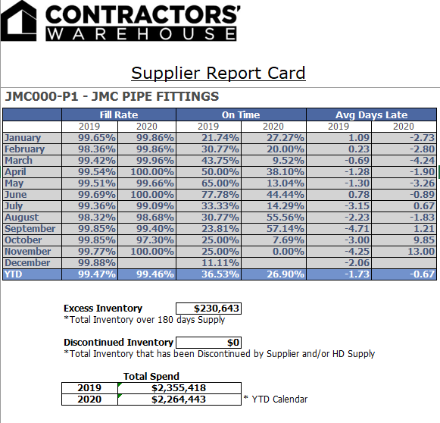

Special Order Program

Contractors’ Warehouse makes every attempt to satisfy the customer’s needs. The Special-Order Program allows us to offer over one million additional products to the customer. Every supplier is expected to offer a special-order program for our warehouses. We can customize the program to ease the ordering process to fit within our and our supplier’s constraints.

Product Information
We need a quick and easy way to reference all of the items that a supplier has available to order that are not part of our stocking program. The following are the three ways we obtain this in- formation. The supplier must choose from one of the three:

- Supplier Literature-Any literature that is supplied to us which displays available product to special order must be approved by the Procurement Manager before any copies can be sent to the warehouses. Requirements include but are not limited to: each page must be on a 8” by 11” sheet of paper, include diagrams and/or pictures of the product, list all sizes avail- able, ordering or part number, and lead time from date ordered to expected date of delivery (if lead time is product specific).

- Supplier Website-A supplier’s website can also be used as a source for product information as long as it contains detailed information on all product. This is a more viable option if the supplier offers too many items to fit in a literature catalogue. Pictures should clearly outline the look and functionality of the product. The website needs to also clearly define all the different variations of an item: colors, sizes, etc. Model or ordering numbers need to be included for easy reference. The website link needs to be provided to the Procurement Man- ager for approval.

- Call Supplier-In the case that the Supplier does not have an approved literature catalogue or website, the supplier must have a representative available to field phone calls from our warehouses. The representative must be available to field calls during our warehouses’ hours of operation. This allows us to handle our customer’s special-order requests seven days a week. The hours of operation are: Monday—Friday, 5:30 am—9:00 pm; Saturday, 6:00 am—7:00 pm; Sunday, 7: am—6:00pm.

Pricing
We require a quick and easy way to obtain pricing for all special-order items available for our customers. The following are the three ways we obtain pricing. The supplier must choose from one of the three:

- Pricing Literature-The supplier may decide to include pricing in their product catalogue or

Special Order Program (continue)

Pricing (continued)
must be on an 8” x 11” sheet of paper, different size, style, or color options listed, model number. Pricing must be specific to style, size, etc. If a multiplier is to be used, then this figure is to be given to the Procurement Manager when the Special-Order Program is set up with that particular supplier. Any change to multiplier must be approved with the Procurement Manager prior to implementation. The multiplier figure is not to be written on any pages of the literature document that is being supplied to the warehouses.

- Call for Quote-If the Supplier does not have any pricing literature then our warehouses will call the supplier directly in order to obtain pricing. It is the Supplier’s responsibility to ensure representatives are available during our operating store hours so that we can obtain and process the Special Order as quickly as possible.

- Computer Software-Some suppliers have easy quoting computer software in which our ordering system links directly to the Supplier’s system in order to obtain pricing and placing an order. Before implementation into our system a copy of the software program needs to be tested by our IT department to ensure the compatibility and functionality of the software in our computer environment.

Order Forms
Suppliers may choose to require their own order form to be used along with our purchase order document. The supplier’s own order form is designed to ease the ordering process by making sure all the information needed to process the order is present. Any discrepancies between our purchase order document and the Supplier’s order form needs to be reconciled prior to shipment. We will not be responsible for product not being delivered correctly due to discrepancies between the two forms.

Cover Sheets
Each special order will be faxed to the Supplier with our own cover sheet document, see page 33 for example. It is important that the cover sheet be filled out with the name of the supplier’s representative processing the order, and an ETA for when the order is expected to deliver to the warehouse. Any change to an ETA needs to be communicated to the warehouse immediately so that we can contact our customer to notify of a change.

Delivery Options
All special orders must follow the prepaid minimum guidelines that are established with the Supplier. If a special order is placed below the prepaid freight minimum amount, then the ware- house can choose to have freight cost added to the order or wait for the order to deliver with the next stock order to be shipped. The agreed upon freight cost must be present on the final copy of the purchase order document to ensure freight is paid on the special order.

New Store Requirements

Opening a new store is a time driven process that requires precise shipments and deliveries from our suppliers in order to ensure our deadlines of grand opening are met. Therefore, we have strict performance guidelines accompanied with all purchase orders that are specified as for a new store. Ample notice of a new store orders will be provided to the supplier. New store orders need to be delivered 100% filled.

When a new store is being opened there will be a one-off renegotiation regarding deviation from standard operating procedure in the Supplier Buyer Agreement including but not limited to free displays, setting of product, terms, labor and marketing funds.

New Supplier Onboarding

Setting up new suppliers requires that a detailed process is followed to ensure that new supplier’s program will have immediate success with Contractors’ Warehouse. No new supplier will be given their opening purchase orders until all of the following guidelines are met.

Supplier Information Worksheet
To be completed in its entirety.

Supplier Buying Agreement
The Supplier Buying Agreement (SBA) document outlines the legal agreement between the Supplier and Contractors’ Warehouse. The SBA document includes information and acceptance regarding terms and conditions, the Contractors’ Warehouse Supplemental Supplier Requirements, general supplier information, payment terms, rebate terms, shipping terms and con- tract end date. Once the contract details are agreed to then both the Supplier Representative and Procurement Manager will sign the document.

Regulation Adherence
We require that all of our suppliers furnish select forms and documents to conduct business with us. These are explained in greater detail on page 39 as it pertains to certificates of liability insurance, material safety data sheets, California Air resources Board compliancy, Volatile Organic Compounds compliancy and warranty information.

Report Card Presidential Contact
We find it important that the high executives for every supplier are aware and engaged in the monthly report cards that are sent out regarding on time deliveries and fill rate. We have the ability to include as many people as possible in the email distribution list. At the very least we need the Supplier’s President’s contact information to ensure top level engagement.

Accounts Payable Manager Discussion
Once a PO is received at the store, the following Wednesday morning a summary bill will systemically be emailed or faxed to the Accounts Receivable contact that shown in our system of all PO’s received for the week prior. Payment will be issued on due date; checks are cut and mailed every Monday, Wednesday, and Friday. All terms begin from the receipt of goods, not the date on the invoice. Debit memos are sent to the same contact as the summary bills. Debit memos are emailed or faxed after receipt of the summary bills. Failure to provide invoice information in the same format as our summary bill will result in either non-payment or late payment

Supply Chain Manager Discussion
The Supply Chain Manager needs to be contacted by the potential supplier’s sales team, ship- ping team, and any other individuals who would benefit from the discussion. The Procurement Manager will also be involved. The discussion will be focused on understanding the Supple- mental Supplier Requirements Guide, and to determine if there will be any issues regarding shipping and/or receiving of product, understanding our expectations when it comes to supplier performance, and any other information deemed important.

Supplier Information
Our finance team requires specific information to ensure payments will be made properly. In- formation includes: copy of the Supplier’s W-9 form, Accounts Receivable (AR) Address, AR contact name and phone number, and fax number to send our summary billing document to, see page 27 for more information.

New Item Setup and Delivery

Contractors’ Warehouse utilizes an efficient, streamlined new item product addition process in order to quickly source, set up and order. A new item setup worksheet has been developed, in excel format, for the supplier to fill out completely, ensuring that all information needed is gathered. See page 38 for a sample of the worksheet.

MSDS Sheets
Contractors’ Warehouse requires that Material Safety Data Sheets are collected for all product that contains hazardous material. If the product Contractors’ Warehouse is setting up as new has an MSDS Sheet, then this needs to be obtained with the New Item Setup worksheet.

Certifications & Restrictions
Suppliers are responsible for adherence to all local laws and regulations. See page 36 for a list of current certifications and restrictions. We will require a copy of certificate of liability, MSDS, VOC compliance, CARB compliance, Prop 65, as well as to include but not limited to a warranty if available.

Description
This description should be complete, without any abbreviations, to fully describe the intricacies of the product being added. This description will be used in the creation of our description shown on the product sign.

Supplier Ordering Number
This is the supplier’s number used to indicate what item Contractors’ Warehouse is ordering. This number will appear on the purchase orders for the supplier’s reference.

Pack Weight
The weight of the pack in pounds. This is utilized when supplier prepaid minimum is set to or- der by pounds.

Pack Size
The order quantity multiple that the product needs to be ordered by.

Unit Cost
The cost of a single unit if ordering by the pack size multiple

MSRP
What is the suggested retail for the item as well as the local and regional market comps.

Unit UPC
The 12-digit UPC-A barcode number of a single selling unit. Contractors’ Warehouse requires a UPC barcode on every item purchased. See page 9 for more information.

Features and Benefits
The supplier is responsible for proving features and benefits for all new items.

High Resolution Picture
Images of product need to be in a JPG format, set to a minimum of 1000 x 1000 pixels. The image should only contain the product, on a white background, with no props or additional product included. If no picture is provided, Contractors’ Warehouse will take photos of the product(s) at the cost of $1000 per SKU.

Supplier Item Maintenance

It is the responsibility of all suppliers to notify the Procurement Manager at Contractors’ Warehouse: of any product changes, including but not limited to cost, model number, pack size, UPC code, discontinuances. An explanation of why the changes are being made must also be submitted in the body of the email sent.

Cost Change Increases
As stated in the Terms and Conditions as part of the Supplier Buying Agreement, increases will become effective 120 days after the Supplier’s receipt of such approval. If you want to position for a cost increase, the Procurement Manager will need to be contacted. Notification information will be required after the Procurement Manager is contacted. Notification information is defined as the Contractors’ Warehouse Item Maintenance form being returned with the cost adjustments listed. The Supplier can submit its own created spreadsheet document providing our SKU number and the proposed cost adjustment. Additionally, a written document explaining the reasons for the cost change, retail comps for our local competitors and any other related information materials are required.

Discontinued Items
It is the Supplier’s responsibility to inform us of any active product that is to be discontinued no less than 90 days prior to the product being unavailable for shipment. Any notice received under 90 days subjects the Supplier to penalties and/or fees. If the Supplier is short shipping discontinued items within the 90-day period, the Report Card fill rate will be affected. The Supplier must also notify us of any comparable replacement product along with its cost, model number, pack size and UPC number. The Supplier is also responsible to assist us in buying back the current inventory and/or a full credit to offset potential loss.

Packaging Change
It is the Supplier’s responsibility to inform us of any active product that is going through pack- aging changes no less than 90 days prior to the packing change being made. All UPC or model number changes because of a packaging change needs approval from the Procurement Manager. If approval is not given, then the item shipped will be treated as a discrepancy as described in detail on page 14.

How to Submit Changes
Contractors’ Warehouse has a specific Item Maintenance Form, see page 37, used to communicate changes to items. These changes include model number, UPC, pack size, description and cost. Whenever a supplier has a pending item change, the Supplier first will communicate the changes to the Procurement Manager. The Supplier is to request an Item Worksheet Form by sending an email to the Procurement Manager. The worksheet will then be sent back to the Procurement Manager. Implementation of requested changes will depend on the Procurement Manager’s approval.

Summary Billing and Payables

Accounts Payable Manager Conversation

Supplier will have conversation/meeting with AP Management to cover items below and answer any subsequent questions regarding said process.

Summary Billing
Contractors’ Warehouse does not accept standard supplier invoices. There is no need to email, fax, or mail paper copies of an invoice. The Summary Billing Statement is sent out on a weekly basis via fax. To ensure prompt payment the Supplier should keep up to date on its summary billing. The Summary Billing Statement (example on page 33) contains information on all purchase orders received that have not been setup for payment in our system. It is the Supplier’s responsibility to return the statement with the invoice reference number and the amount invoiced. Any discrepancy reports sent to a supplier informing them to adjust in- voice will be automatically adjusted on the check. A purchase order will be removed from the summary billing statement when either the payment information is received or 90 days after the purchase order has been received. We will not payback any discount taken if a summary billing statement is submitted after the payment due date for the specific purchase orders. If the Sup- plier decides to not use the summary billing statement that is supplied by us, then the Supplier may create its own document in pdf or excel format and send to hdsr&raccountspayable@contractorswarehouse.com as long as the document follows these basic instructions:

- Our warehouse number, purchase order number, the Supplier’s invoice number and the in- voice amount.
- The required information must be formatted into four columns, with the warehouse number, purchase orders number, invoice number and invoice amount being used as the header for each column.
- The columns must follow the sequence listed above.
- Each row represents a different purchase order to be paid.

If a supplier submits an incorrectly formatted or incomplete summary billing statement, purchase order payments will not be set up. It is the Supplier’s responsibility to correct and re- submit the summary billing statement.

Payment Terms
Contractors’ Warehouse is committed to paying our suppliers on time. Checks will be mailed on the check run day following the terms conclusion specified on the purchase orders. Payment terms begin once the product is received, unless otherwise annotated. We do not respond to payment inquiry requests for purchase orders less than 14 days past due.

Any product that is ordered and either does not arrive with the shipment, arrives incorrectly (wrong model number or UPC) or arrives in unsellable for full retail condition (missing UPC, packaging defect) will not be received into the warehouse.

Summary Billing and Payables (continued)

Payment Terms (continued)
discrepancy report stating the issue and the product for which payment will be shorted. We will not pay for the items shorted as specified on the discrepancy report; therefore, the invoice payment amount should be adjusted accordingly.

Paper Invoices
We only pay off of summary billing statement. Do not send paper or electronic invoices.

Post Shipment Pricing Discrepancies
All pricing discrepancies must be remedied prior to the shipment of product. We only pay the stated purchase order cost for each line item.

Non-pricing Discrepancies
All other discrepancies that occur for non-pricing issues will be reviewed at the Supplier’s re- quest. The Supplier needs to ensure it was not sent a discrepancy report pertaining to the issue at hand. If we find in favor of the Supplier, then payment for the amount debited will be adjust- ed on the next check that the Supplier receives. If we find the Supplier’s claim to be not valid or if it is proven that the Supplier did receive the discrepancy report, then we will not pay back the debit in question. Proof of discrepancy report being sent will include a copy of the successful fax transmission with the Supplier’s fax number listed.

Sample Forms

This section contains sample forms and examples for the Supplier to use as aides for making sure it is keeping in compliance with Contractors’ Warehouse Requirements

Purchase Order Cover Page

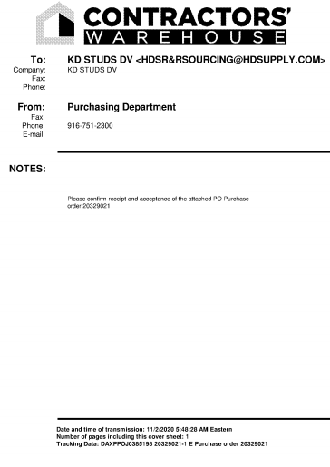

Purchase Order

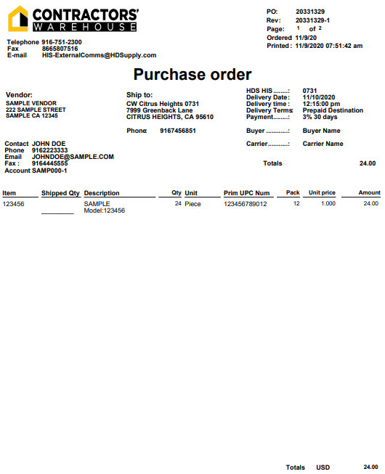

Discrepancy Report

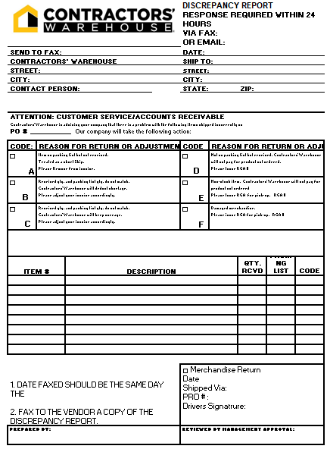

Late Purchase Order Notice

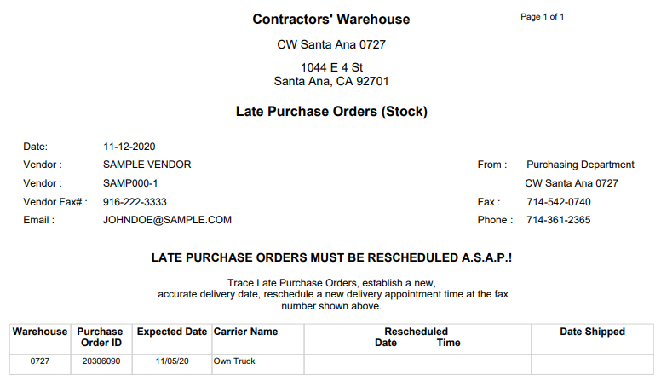

Request for Returned Goods Authorization

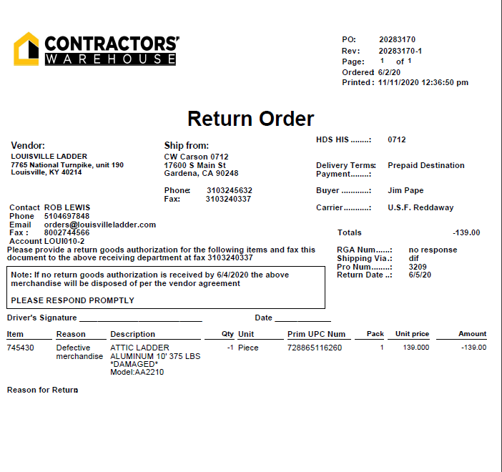

Summary Billing Statement

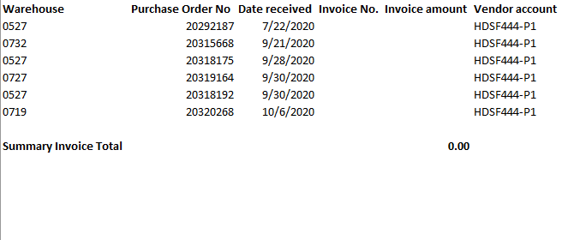

Check Stub Example

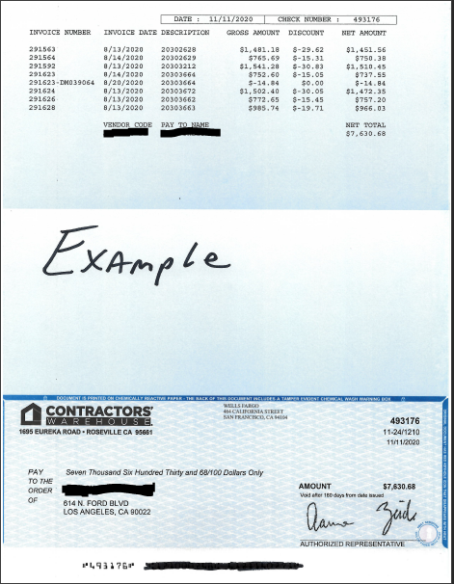

New Item Setup Worksheet

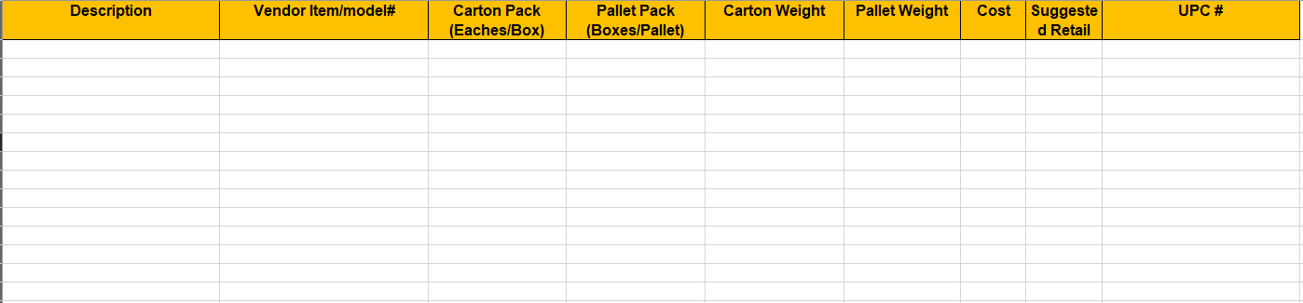

Regulation Adherence

We require our suppliers to provide select forms and documents; additionally, it is the responsibility of the Supplier to ensure these forms and documents are updated. The Certificate of Liability, which is mailed to ATTN: Compliance Team, 1695 Eureka Road, Roseville CA 95661.

As stated in the Terms and Conditions as part of the Supplier Buying Agreement: Supplier represents that all products comply with all applicable federal, state, and local laws, codes (including building codes), statutes, ordinances, rules, regulations and requirements of the country or origin, the country of transit, or any applicable country or jurisdiction, and orders of any governmental or regulatory authority, including but not limited to the Consumer Product Safety Act; Magnuson-Moss Warranty-Federal Trade Commission Improvement Act; the Fair Packaging and Labeling Act; the Textile Fiber Products Indemnification Act; the Flammable Fabrics Act; the Wool Products Labeling Act; the Federal Food, Drug, and Cosmetic Act; The Federal Hazardous Substances Act; the Safe Drinking Water and Toxic Enforcement Act of 1986; all applicable rules and regulations regarding maximum volatile organic compound content and associated markings; all applicable rules and regulations regarding fees, assessments and record keeping requirements associated with the sale of pesticides; the Federal Energy Policy and Conservation Act; all applicable rules and regulations of the federal Trade Commission; the U.S. Food and Drug administration, and any other federal, state, or local agency (collectively, the “Law” or the “Laws”) and that any changes to the products hereafter made by the Supplier shall comply with all applicable Laws.

Certificate of Liability
We require suppliers to provide us with a paper copy of their certificate of liability insurance form. Since these insurance forms expire yearly, it is the Supplier’s responsibility to keep us updated with its most current form. Page 41 is an example form including the minimum cover- age requirements.

Material Safety Data Sheet (MSDS)
For a item requiring a MSDS, we must receive a copy from the Supplier during the setup of the item. Page 42 is a sample MSDS and displays the required information. No item will be received by the warehouse unless the MSDS is on file. For any item not requiring a MSDS, the Supplier must specify this for our records. Any changes made to an item requiring a modification to the MSDS (i.e. a new MSDS), the Supplier must submit to us no less than 30 days prior to the product being shipped to the warehouse.

WERCSmart System Compliance
To avoid costly fees of non-compliant chemically containing products, suppliers of chemical- containing products are required to participate in the WERCSmart System program. Regulatory compliance requirements for all chemicals include but are not limited to private labeled chemical, aerosols, architectural coating, adhesives and sealants, solvents and paint thinners, and consumer products. Supplier will need to register their products in the WERCSmart system. WERCSmart will then perform compliance assessment of each product and support HD Sup- ply’s regulatory compliance goals. To register your product go to www.supplierwercs.com and create a WERCSmart account. Failure to register a product will result in product not being purchased or sold in Contractors’ Warehouse stores until registration is complete. For more information you may contact the Contractors’ Warehouse WERCSmart team at wercsinfo@hdsupply.com.

CARB Compliant Acknowledgement
In April 2007, the California Air Resources Board (CARB) approved an airborne toxic control measure

Regulation Adherence (continued)

(ATCM) to reduce formaldehyde emissions from composite wood product panels and from finished goods that contain composite wood products. Businesses required to comply with the ATCM include manufacturers, importers, distributors, fabricators and retailers of composite wood products and finished goods.

As a supplier to Contractors’ Warehouse, it is your sole responsibility to ensure compliance with all applicable regulations. In an effort to help ensure that complying composite wood products and finished goods are purchased, we are instructing each supplier, fabricator and distributor that the goods it supplies must comply with the applicable emission standards. Contractors’ Warehouse requires every supplier to submit the CARB Compliant Acknowledgement form, page 44, stating the Supplier either does not manufacture, import, distribute, or fabricate composite wood product, or the product is compliant with the ATCM.
The ATCM can be viewed at: http://www.arb.ca.gov/toxics/compwood/compwood.html Note: If you check the opt in option on the acknowledgement form, a further discussion with
the Procurement Manager must take place to ensure proper CARB labeling and packaging compliance is being met.

Volatile Organic Compound (VOC)
It is the responsibility of the supplier to ensure all items supplied to us do NOT contain volatile organic compounds in excess of the limits specified in the California Code of Regulations and the Regional Air Quality District.

Warranty
The supplier must submit to us a copy of the warranty for all products making a warranty claim. The copy must be submitted during the setup of the item. No item will be received by the warehouse until a copy is on file. All products making a warranty claim must reference a con- tact source for consumer to exercise their warranty rights.

Certificate of Liability

*Minimum requirements vary per product group; please contact your Procurement Manager for specifics.

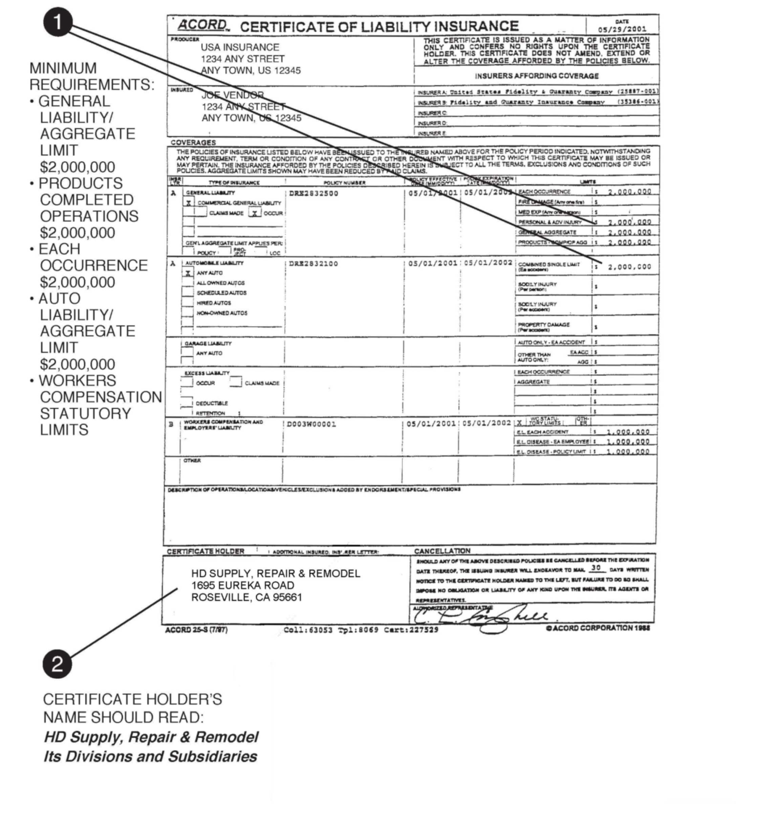
CONTRACTORS’ WAREHOUSE
1695 EUREKA ROAD
ROSEVILLE, CA 95661
CONTRACTORS’ WAREHOUSE
1695 EUREKA ROAD
ROSEVILLE, CA 95661



